CO1-AT1-Case Study Analysis Report
Problem Statement: Smart E-commerce Order Fulfillment Platform
NAME: D. Nikhil Reddy SLOT: D
REGNO: 192325045 COURSE CODE: CSA1007
1. Understand the Problem Statement
- The Smart E-commerce Order Fulfillment Platform is designed to automate and optimize order processing, inventory allocation, and delivery logistics for large-scale e-commerce operations.
- Objectives: Manage orders, optimize fulfillment, predict delivery delays, notify customers, and generate logistics reports.
- Scope: Order management, inventory monitoring, fulfillment center allocation, delivery route optimization, delay prediction, and customer notification.
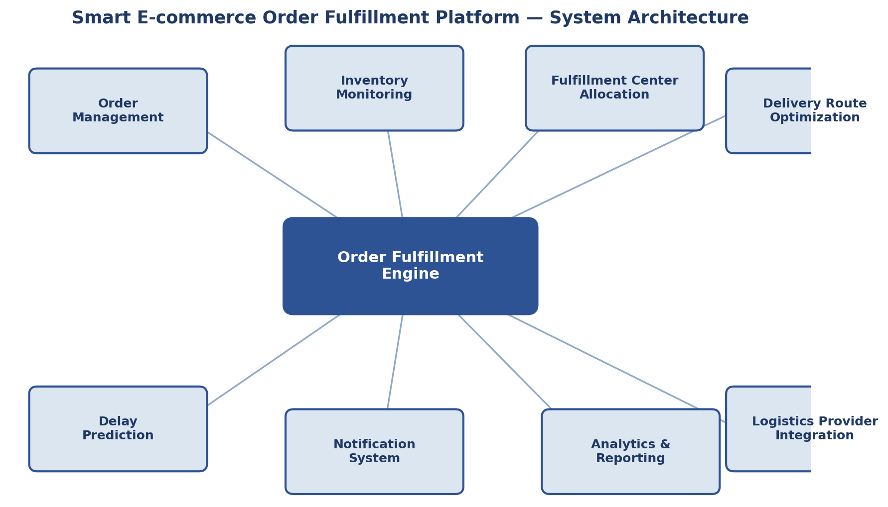
Fig 1: System Architecture of the Smart E-commerce Order Fulfillment Platform
2. Identify Key Stakeholders and Challenges
- Stakeholders: E-commerce Business Managers, Warehouse Staff, Logistics Providers, Customers, IT Administrators, Customer Support Teams.
- Roles: Business managers oversee operations; warehouse staff handle inventory and packing; logistics providers manage deliveries; IT teams maintain the system; support teams handle customer queries.
- Challenges: Shipment delays, incorrect order processing, poor coordination between systems, demand spikes during seasonal sales, and rising shipping costs.
3. Analyze the Current Approach
- Current Process: Manual coordination between inventory, warehouse, and logistics systems using fragmented software solutions.
- Strengths: Established order processing workflows and existing logistics partnerships.
- Limitations: Delayed shipment detection, error-prone manual allocation, poor scalability during demand surges, and limited predictive capability.
- Gaps: Lack of real-time inventory visibility, automated delay prediction, and centralized fulfillment coordination.
4. Proposed Software Solution Using Software Engineering Principles
- Modules: Order Management, Inventory Monitoring, Fulfillment Center Allocation, Delivery Route Optimization, Delay Prediction, Notification System, Analytics & Reporting.
- Functional Requirements: Track orders, monitor inventory and warehouse capacity, assign fulfillment centers, optimize delivery routes, predict shipping delays, notify customers, and generate performance analytics.
- Non-Functional Requirements: Scalability, reliability, security, performance, usability, and maintainability.
- Software Engineering Principles: Modular and distributed architecture, scalable design for demand spikes, secure data handling, real-time processing, and user-friendly dashboards.
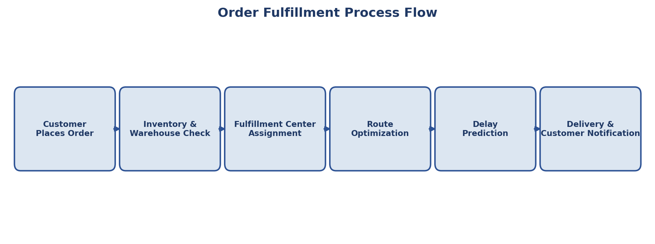
Fig 2: Order Fulfillment Process Flow
5. Justify the Chosen Methodology/Framework
- Selected SDLC Model: Agile Scrum.
- Justification: Supports incremental development of modules, continuous feedback from stakeholders, and rapid adaptation to seasonal demand changes.
- Benefits: Improves cross-team collaboration, reduces project risk, and simplifies maintenance.
6. Expected Outcomes and Limitations
- Expected Outcomes: Faster deliveries, reduced shipping costs, improved customer satisfaction, better inventory utilization, and higher operational efficiency.
- How Challenges Are Addressed: Real-time inventory tracking, predictive delay analytics, automated fulfillment center assignment, and proactive customer notifications.
- Limitations: Dependency on accurate real-time data, integration complexity with third-party logistics providers, initial infrastructure cost, and staff training requirements.
- Future Enhancements: AI-based demand forecasting, autonomous/drone delivery integration, blockchain-based supply chain tracking, and expanded cloud infrastructure.
Code of Conduct:
I D. Nikhil Reddy - 192325045 (Name / Reg No) certify that this submission is my original work and that I have adhered to the guidelines specified for this assessment. I understand that any violation of academic integrity rules will result in disciplinary action.
Signature of the student:
D. Nikhil Reddy

